Question 3

(a) There is a clear seasonal pattern: the temperature in plot rises and falls periodically over the course of the year.

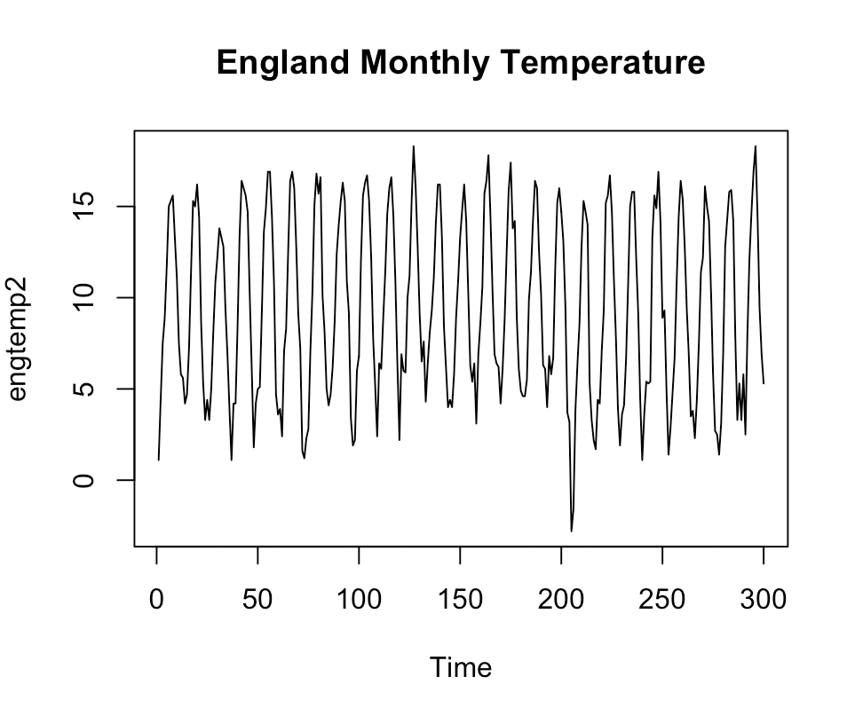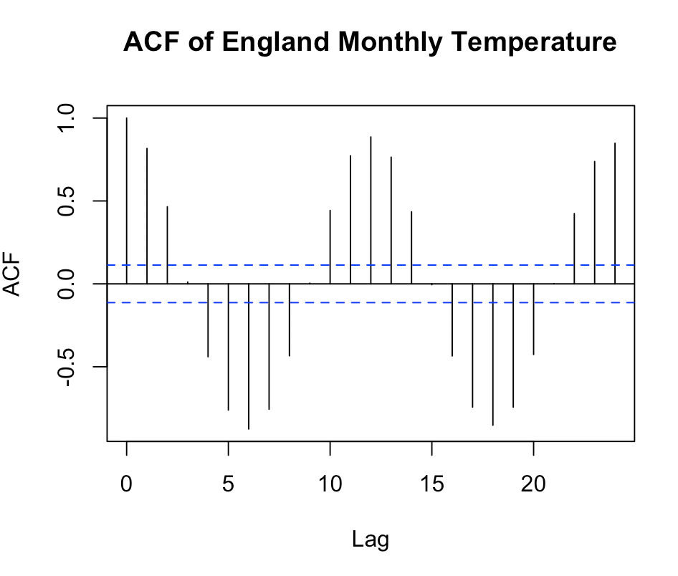

(b) $β_{1}=9.21731$, $β_{2}=-5.15517$, $β_{3}=-3.88514$

(c) There exists dependency to some extend for residuals, because several lags show correlation higher than the range. The residuals are fairly stationary, although there are some indications that this may not be the case. Overall, the residuals are more stationary than the original series.

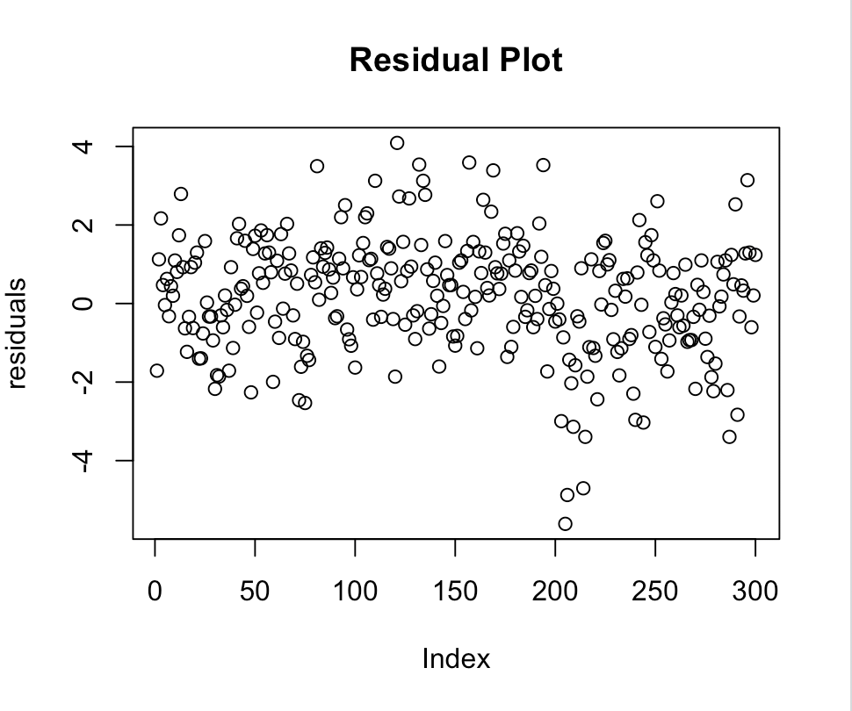 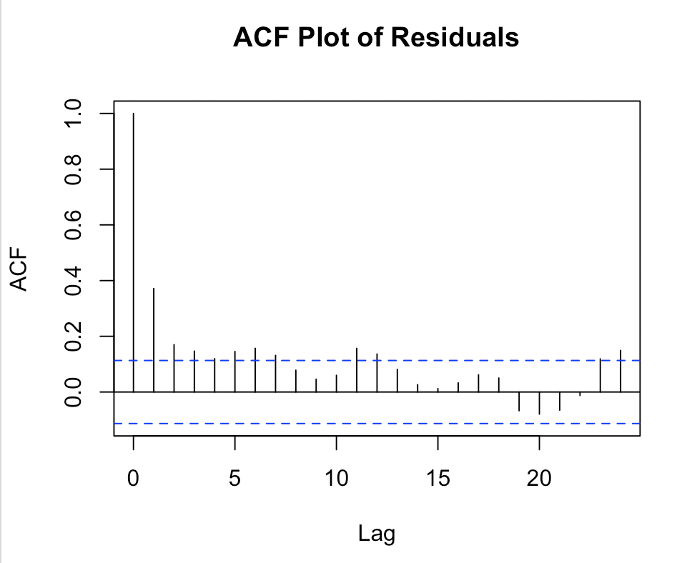

(d) We successfully removed a large part of periodical trend, but the ACF plot indicates that there may be some other trends left.

Question 4

(a) Since we are using weekly data to evaluate yearly data, the weights are as follows

$$a_{0}=a_{±1}=…=a_{±25}=\frac{1}{52}, a_{±26}=\frac{1}{104}$$

(b) From 2000 to 2008, the oil price increased continuously but experienced a drop in 2009. Beginning 2010, the oil price went up again.

